## <Manager>Remove Task

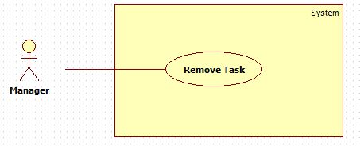

**Figure 1 Remove Task**

|  |  |  |  |
| --- | --- | --- | --- |
| **USE CASE –UC001** | | | |
| **Use Case No.** | UC001 | **Use Case Version** | 1.0 |
| **Use Case Name** | Remove Task | | |
| **Author** | Tran Thi Kim Anh | | |
| **Date** | 02/06/2015 | **Priority** | Normal |
| **Actor:**   * Manager.   **Summary:**   * This use-case allows manager to remove tasks that didn’t require or was done in project.   **Goal:**   * Manager can remove tasks from the screen.   **Triggers:**   * Manager clicks “Remove” button in Task Detail Page.   **Preconditions**:   * User must login with Manager Role.   **Post Conditions:**   * **Success**: At List Task Page, it has not tasks that were removed. * **Fail**: System shows error message.   **Main Success Scenario:**   |  |  |  | | --- | --- | --- | | Step | Actor Action | System Response | | 1 | Click a Task. | System transfer to Task Detail Page. After, system show detail of a task. | | 2 | Click “Remove” button. | System shows a pop-up with content: “Are you sure remove this task?”, “OK” and “Cancel” button. | | 3 | Click “OK” button.  [Alternative 1] | System shows a pop-up with content: “Task was removed successfully.” |   **Alternative Scenario:**   |  |  |  | | --- | --- | --- | | No | Actor Action | System Response | | 1 | Click “Cancel” button. | System closes pop-up and backs Task Detail Page. |   **Exceptions:** N/A  **Relationships**: N/A  **Business Rules:**   * “Remove” button only shows in screen of manager. * After remove tasks, at list tasks all list tasks are shown except removed tasks. * Director can remove task. * A task is removed when it has “New” status. | | | |

## <Director>Create Project

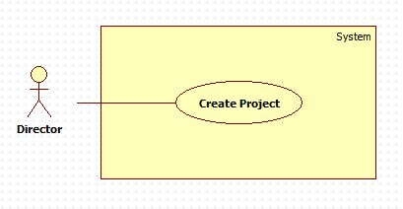

**Figure 2 <Director>Create Project**

|  |  |  |  |
| --- | --- | --- | --- |
| **USE CASE –UC002** | | | |
| **Use Case No.** | UC002 | **Use Case Version** | 1.0 |
| **Use Case Name** | Create Project | | |
| **Author** | Tran Thi Kim Anh | | |
| **Date** | 02/06/2015 | **Priority** | Normal |
| **Actor:**   * Director.   **Summary:**   * This use-case allows director to create a new project, and can assign managers and member to join in project.   **Goal:**   * Director create a new project.   **Triggers:**   * Director clicks “Create Project” in Director Page.   **Preconditions**:   * User must login with Director Role.   **Post Conditions:**   * **Success**: In Director Page, a new project will appear. System will send a notification to announce to manager. And in database, it will save a new data. * **Fail**: System shows error message.   **Main Success Scenario:**   |  |  |  | | --- | --- | --- | | Step | Actor Action | System Response | | 1 | Click “Create Project” button. | System shows a pop-up with contents:   * Project ID : int * Project Name : String * Creator : String * Create Date: datetime * Deadline : datetime * Description: String * Assignee: String * “Create” and “Cancel” button.   [Exception 1] | | 2 | Add information and click “OK” button.  [Alternative 1] | System show announce “Project was created successfully”. And back to Director Page. |   **Alternative Scenario:**   |  |  |  | | --- | --- | --- | | No | Actor Action | System Response | | 1 | Click “Cancel” button. | System will back to Director Page. |   **Exceptions:**   |  |  |  | | --- | --- | --- | | No | Actor Action | System Response | | 1 | Input deadline that is small than create date. | System will show a warning “Deadline must be large than create date”. |   **Relationships**: N/A  **Business Rules:**   * After create project, at List Project, new projects are shown and sort the first. * When a new project is not assign member, it has “New” status. | | | |

## <Director>Update Project

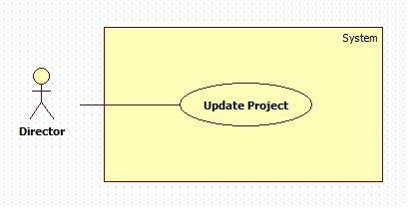

**Figure 3 <Director>Update Project**

|  |  |  |  |
| --- | --- | --- | --- |
| **USE CASE –UC003** | | | |
| **Use Case No.** | UC003 | **Use Case Version** | 1.0 |
| **Use Case Name** | Update Project | | |
| **Author** | Tran Thi Kim Anh | | |
| **Date** | 02/06/2015 | **Priority** | Normal |
| **Actor:**   * Director.   **Summary:**   * This use-case allows director to edit projects that has in database and was shown on screen.   **Goal:**   * Director can edit content of project as member, description, deadline, so on.   **Triggers:**   * Director will click “Edit” button in Project Detail Page.   **Preconditions**:   * User must login with Director Role.   **Post Conditions:**   * **Success**: New information will save in database and show in Project Detail Page. * **Fail**: System shows error message.   **Main Success Scenario:**   |  |  |  | | --- | --- | --- | | Step | Actor Action | System Response | | 1 | Click “View Detail” of Project. | System shows Project Detail Page include 2 tab:   * Tab 1: Contents of Project and “Edit” button. * Tab 2: Project Member and “Add”, “Remove” button. At tab 2, Members are shown in a table. | | 2 | In tab 1, click “Edit” button. | System shows a pop-up with contents:  Skills, Deadline, so on. | | 3 | Add all information that need change, click “OK” button.  [Alternative 1] | System show information that was changed in Project Detail Page. | | 4 | In tab 2, click “Add” button. | System shows a pop-up include 2 tab:   * Tab 1: Add member by typing. * Tab 2: Add member by suggest follow skills. | | 5 | Choose tab 1 or 2, then click “OK button.  [Alternative 2] | System shows new member in Tab 2 Project Member on Project Detail Page. |   **Alternative Scenario:**   |  |  |  | | --- | --- | --- | | No | Actor Action | System Response | | 1 | Click “Cancel” button. | Back to Project Detail Page. | | 2 | Click “Cancel” button. | Back to Project Detail Page. |   **Exceptions:** N/A  **Relationships**: N/A  **Business Rules:**   * Update Project function only was used by director. So manager will not see “Edit” button. * After update project, new information will show in Detail Project Page, and data will saved in database. | | | |